Perseid User’s Guide
Updated 2019 Nov 12

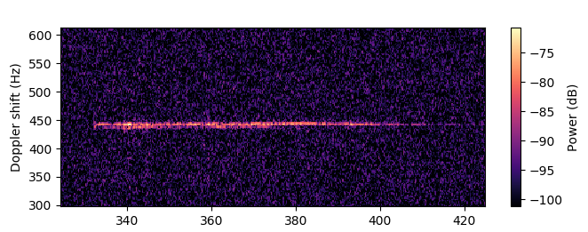

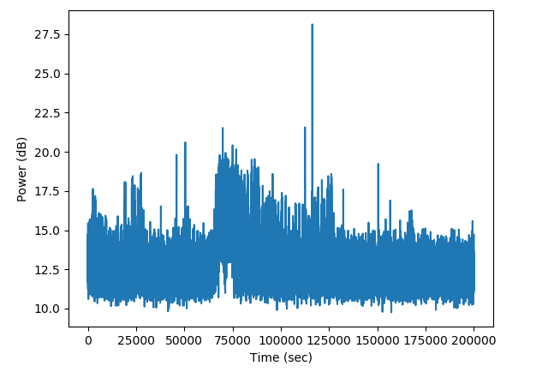

Introduction
Perseid is a GUI utility for finding meteor echoes in I/Q data. It was written for the Vancouver Centre of the Royal Astronomical Society of Canada as part of their amateur radio astronomy initiative.

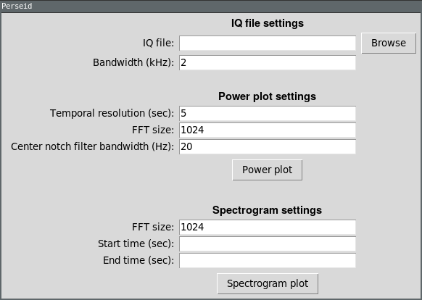

Perseid is simple to use. A typical workflow looks like:

- An IQ file to be analyzed is selected.
- An interactive “power plot” is generated that will show spikes in signal power on the y-axis against time on the x-axis.
- Interesting events (tall thin spikes) are easily seen on the plot and the plot can be zoomed in to reveal more detail.
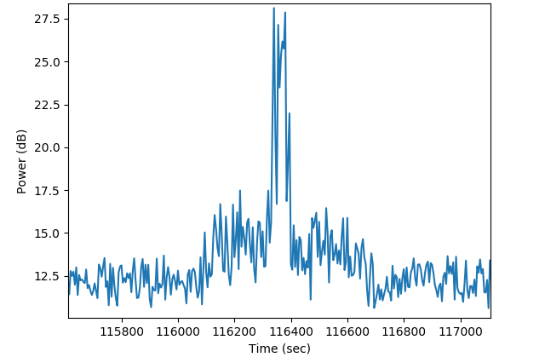
- The begin and end times are noted for the event (in the above figure, 116000 and 116800) and entered in as the spectrogram start and end time on the main window.
- An interactive spectrogram is generated for the event and can be zoomed/panned.
- Once the echo is revealed in sufficient detail, a figure can be saved.

Windows Installation

Python Setup
First download the latest WinPython. Run the executable and extract its contents to a safe directory, for example C:\WinPython.

After extraction is complete, run the “WinPython Control Panel” executable in the WinPython directory. Under the “Advanced” menu, click “Register distribution…”. Hit yes to continue. Close the WinPython control panel application.

Downloading Perseid
Download Perseid from here. Double-click the file and it should open with WinPython. If that doesn’t work, associate .pyw files with the pythonw executable inside the WinPython\python-x.x.x.amd64 directory and try again.

Parameter Descriptions

IQ File Settings

Bandwidth (kHz) | The sample rate of the IQ file. The meteor detection GRC file should put the bandwidth in the filename. An incorrect value for this parameter will cause the plots to have the wrong scaling on the time axis.

Power Plot Settings

Temporal resolution (sec) | The amount of time each datapoint on the power plot will represent. A smaller value here will make the plot more sensitive to shorter events and will take more time to process. Meteor trails typically last a few seconds, so a value of at least 1 second is recommended.
FFT size | This will determine the spectral resolution used during the processing of the power plot. A value too small will cause the plot to not be sensitive to meteor events, and a value too high will make the plot take needlessly long to process.
Center notch filter bandwidth (Hz) | How much spectrum should be notched out from the center of the capture. This is useful if the carrier signal from the TV transmitter is present.

Spectrogram Settings

FFT size | This will determine the spectral resolution of the spectrogram plot. However, there is a tradeoff with temporal resolution. A larger FFT size will cause the plot to be less detailed in time but more detailed in frequency, and a smaller FFT size will cause the plot to be more detailed in time but less detailed in frequency. It’s recommended to experiment with this parameter for a given meteor event. This parameter must be a power of 2 (64, 128, 256, 512, 1024, …).
Start time (sec) | The start time of the plot.
End time (sec) | The end time of the plot.

